# Model

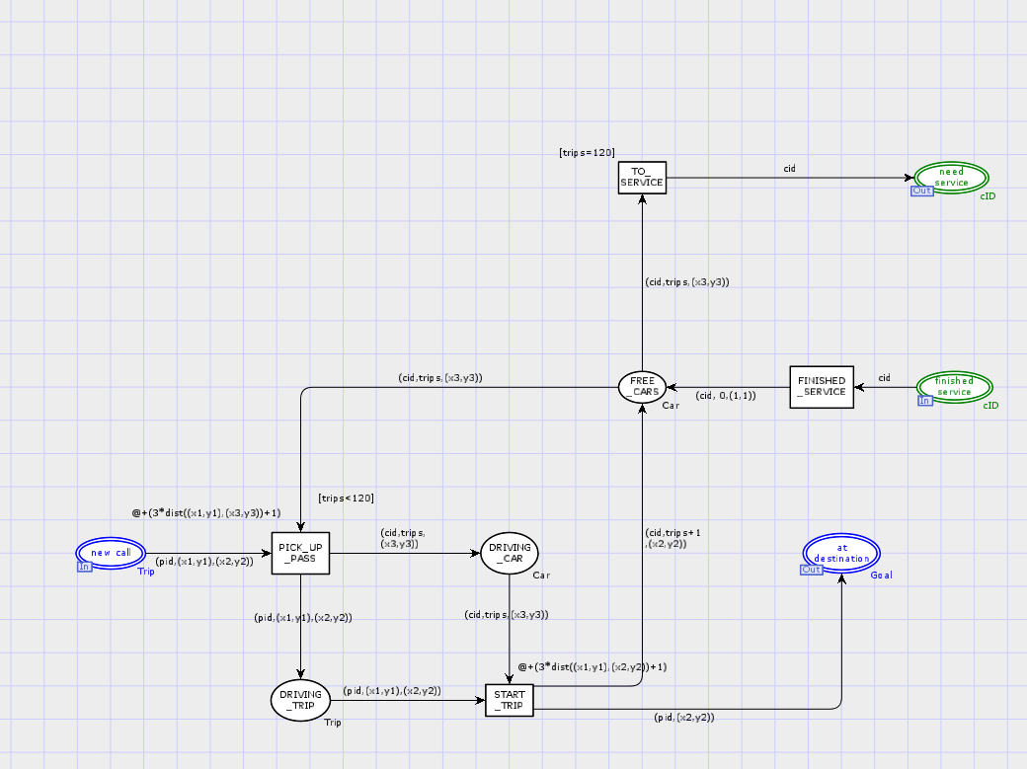

# Model Description

* After a car completed service in the garage, its car id is available in place (finished service). From there it takes transition FINISHED_SERVICE to place FREE_CARS. FINISHED_SERVICE adds the cid to its corresponding car with full charge and 0 trips and position (1,1).
* From FREE_CARS the car can either be serviced or it can be used to pick up a new TRIP.
* If the Car has finished 120 trips it must take the TO_SERVICE transition and be serviced.
* When a Trip is to be picked up by a Car, their corresponding times are updated. The Trip then goes to the DRIVING_TRIP place and the Car goes to the DRIVING_CAR place.
* Once the Car has picked up the Trip, the Car drops off the Trip at the destination. In this step the time and number of trips both are updated respectively. After this step the Car is back in the FREE_CARS place.

# Declarations, Guards, Arc Inscriptions, Functions

## Declarations

|  |  |
| --- | --- |
| X3,y3 | Variables of type INT |
| Car | a collection of information representing a car. A Car contains a cid, an integer representing the amount of trips since the last service, an integer representing the remaining charge, and a location representing the cars current location |

## Guards and Arc Inscriptions

|  |  |  |
| --- | --- | --- |
| Guard/Arc Inscription | Where is it in the model? | Explanation |
| @+(3*dist((x1,y1),(x3,y3))+1) | This is attached to the PICK_UP_PASS transition | This updates the Trip and Car with the amount of time it takes for the car to travel to the starting location of the Trip and pick it up. |

# Simulation Results

## Summary of Simulation Results

From the simulation report it can be seen that my model always completes 1000 trips successfully with on average only 47 trips taking too long.

## Raw Simulation Reports

